Payment Detail Design

DOC. No.: | REV.: 00 |  |  | PRODUCT:
TITLE: Payment Detail Design |  |  |  | Project: | SL15/SL1000
Prepared by: | Ray |  |  | Date:
Remark: | Approval:
Remark: |  | Department | Title |  |  | Signature
Remark: | 1 | Electronic R&D
Remark: | 2
Remark: | 3
Remark: | 4

Revision | Description of Change | Author | Date
00

1. Overview 4
1.1. Objective 4
1.2. Scope 4
1.3. Reference 4
1.4. Abbreviations 4
2. Logical architecture 4
3. Interface design 4
4. Thread model 6
5. The thread adapt layer 7
6. Synchronize with MDB cashless device 8
7. The consistency of revalue operation 8
8. CreditMgr State 9
9. Multi credit types: 9

Overview

Objective

Scope
This document describes the design issues of payment module.

Reference
Please via docs\Detail design\classDiagram.uml in SVN for detail class diagram.

Abbreviations

Logical architecture

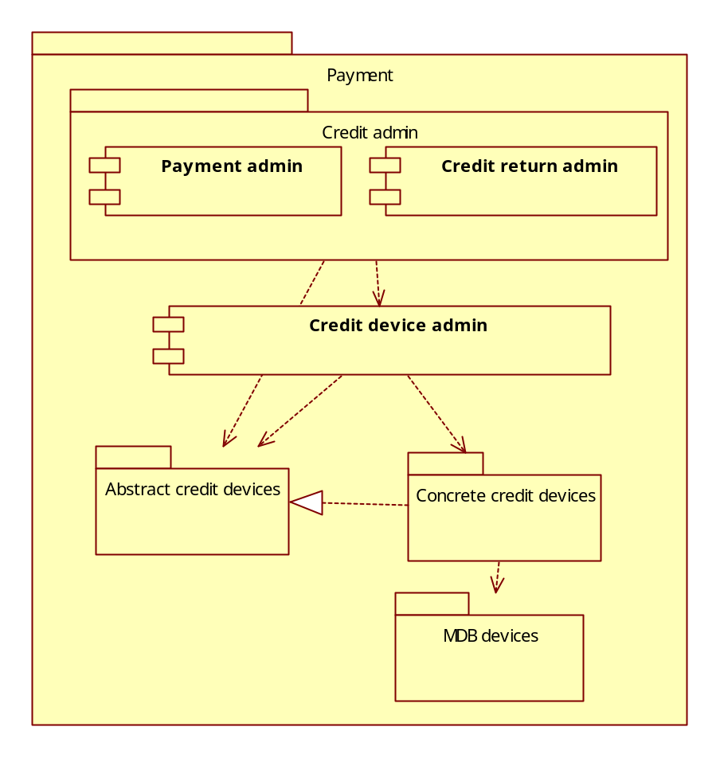

Interface design

To minimize the dependency among modules, payment device are design based on interface, payment device should implement and only implement interfaces they can support.
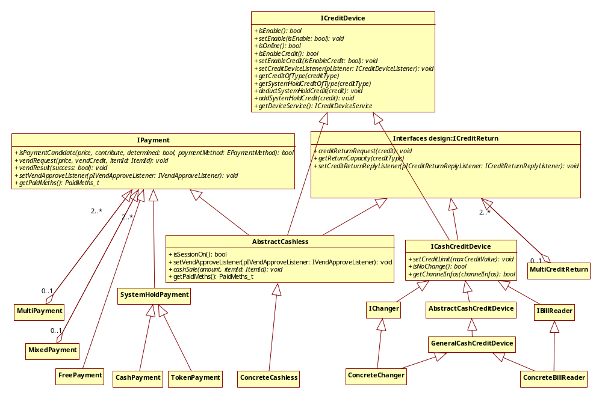
ICreditDevice is common interface for all kind of real payment devices, i.e. cashless card reader, changer and bill reader.

IPayment is the interface for payment operation. Beside Cashless which is a real payment device that implements this interface, there are some other ‘virtual devices’ (FreePayment, CashPayment, MixedPayment)

Changer and Bill reader do not implement IPayment interface, instead all cash payment are handled by CashPayment class.

ICreditReturn interface is for returning credit to customer, for changers actually dispense coins; and for cashless revalues credit to card. Class MultiCreditReturn is to support return credit through multiple devices, i.e. try ICreditReturn interfaces one by one.

Some Payment device’s function may take times to complete; these functions are implemented in asynchronous manner. In addition payment device also need to report instant events to VMC, Call back interfaces named with ‘xxxListener’ are for this purpose.
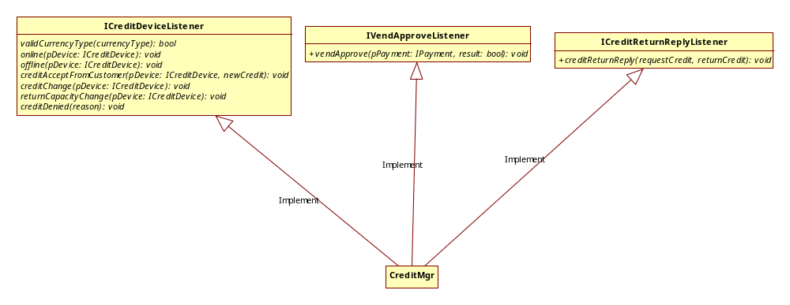

Thread model
Some commands of MDB payment devices may take seconds to complete, to avoid blocking the main thread, every MDB payment device run in its own thread context; communication between main thread and device thread are all asynchronous.
See the below diagram, MDBChanger and MDBCashless which handle MDB specific commands are run in standalone threads.
All other payment management logics are run in main thread.

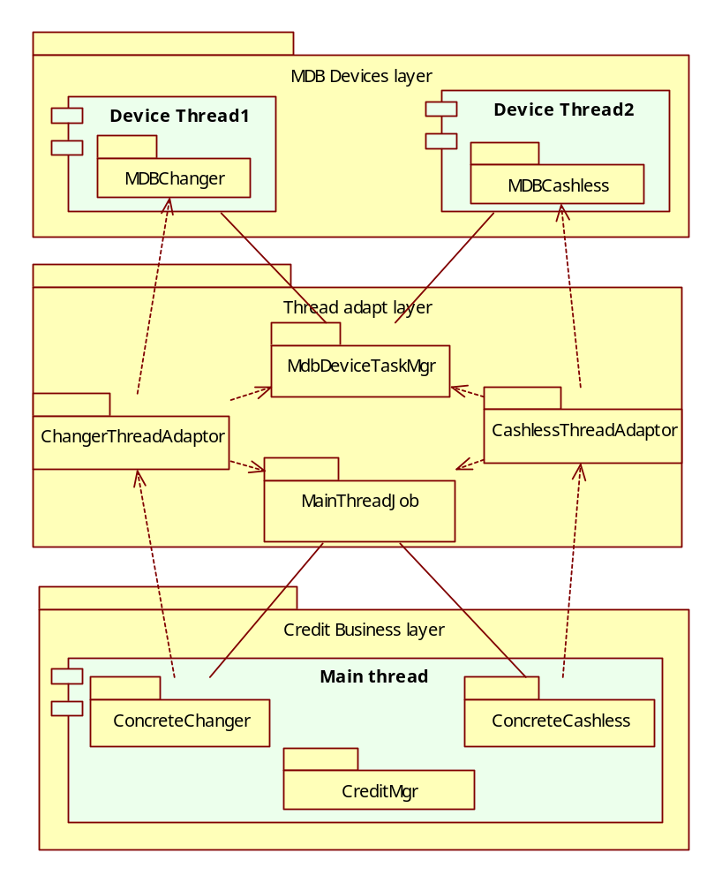

The thread adapt layer
To support asynchronous message between main thread and a device thread, and eliminate the trivial message dispatching blocks, we have tried to apply boost function (boost is an open source platform independent c++ library) to redirect commands between threads.
For example, if you want to run a function in main thread context but currently in device’s thread context:

Class A
{
Void fun1(int i);
};
typedef boost::function<void()> JobFun;
A a;
A * g_pA=&a;

//Code for send messages in device’s thread context:
extern A * g_pA;
JobFun myfun;
myfun=boost::bind(&ClassA::fun1, g_pA,8); //bind 8 to i
SendMessage(m_hWnd,WM_MAIN_THREAD_JOB,(WPARAM)&myfun,0);

//In the main thread message handle for WM_MAIN_THREAD_JOB:
LRESULT MainThreadJobWin::onMainThreadJob(UINT wParam, LONG lParam)
{
JobFun *pMsg=( JobFun *)wParam;
pMsg->(); //run the function
}

Module MainThreadJob is for redirect command from device thread to main thread, and module MdbDeviceTaskMgr is for the opposite direction.

Synchronize with MDB cashless device
The asynchronous communication between MDBCashless and CreditMgr brings an synchronous issue, i.e. the CreditMgr can not always obtain the latest state of the payment device. Assume this scenario: VMC determine a card session has started from previous received messages but at that moment the session has indeed been closed, but the new message still in queue, and what happen if CreditMgr send a vend request command to MDBCashless.

The MDBCashless module should deal with this situation, not sent Vend Request command to the device in this case, for some device may reply COMMAND OUT OF SEQUENCE and result in resetting the device inevitably.

In addition MDBCashless should ensure sending reply back to CreditMgr for these commands (vendRequest, revalueRequest), event in above situations. Other wise the CreditMgr would keep waiting for reply.

Apply these measures in MDBCashless:
State machine is to setup to keep tracking the current device state.
Timeout mechanism is to be introduced, vide the next part about the FAGE GIODY reader for reason.

The consistency of revalue operation
How to deal with the accidents occur when revalue in progress, and when accident occurs, how to determine the revalue operation is success or failed?
Card ejected by customer
Different type readers have distinct behavior. For example,
The UTL4 model of MICROTRONIC always reply Revalue Approved or Revalue Denied followed with a Session Cancel
Request (In rare case it may abnormally reply Revalue Approved followed with Revalue Denied).
And the FAGE GIODY model just holds in a special state, except ACK no further reply, and reset command is required to leave this state.
For my opinion, if revalue operation succeed, reply of Revalue Approved should be received, other cases can be treated as failure.

Max No Response time passed and device has been reset
In this case there no convenient way to judge whether revalue operation is success or not. (The only way is to compare the previous balance before operation, but the procedure is complex and need customer interaction).
For this case have race chance occur, we implement it in a simple way, treated it as failure.

CreditMgr State
How to deal with the situation when command is sent to CreditMgr but it is busy (serving for other command or something other)? There 3 solutions:

- Post the job to a queue, and inform busy message to user. And as son as the previous job complete, the CreditMgr would get the job from the queue and execute it.
Con: Would it bring synchronizing problem?
- Just reject the command. User may receive message like “Credit busy, please try again later”.
- The CreditMgr just reject the command, and the calling module’s responsibility of making decision whether to retry or raise an error.

Multi credit types:
It seems multiple credit types issue is inevitable in asynchronous environment.
Although we try to block credit which is not compatible to current accepted credit, but this not always does, cash and token may be both accepted at the same time.

Error code define

Coin mechanism error
EVA error code | Event description | Definition | Is Fatal | Define
EA_1 | Data out of boundary | Data out of boundary when communicate between VMC and pay device. | No | PdErrOutOfBoundary
EA_2 | Protocol error | Communication protocol error | No | PdErrProtocol
EA_3 | Low device level | The device’s level is not high enough for VMC requirement | No | PdErrLevel
EA_4 | Country code not recognized | The country code reported by device is not recognized by VMC | No | PdErrCurrencyUnresolved
EA_5 | Country code not match | The country code reported by device does not match VMC setting | No | PdErrCurrencyMismatch
EA_6 | Decimal point not match | Device’s decimal point does not match VMC setting | No | PdErrDecimalPlaceIncompatible
EA_7 | Reset unexpectedly | Device reset unexpectedly | No | PdErrUnexpectedReset
EA_8 | Payout data truncated | Data truncated when VMC try to send payout command to device | No | PdErrCashPayoutTruncated
EA_9 | Feature absent | VMC find device absent necessary feature. | No | PdErrFeatureAbsent
EA_10 | Invalid cash channel number | Device reported invalid cash channel number | No | PdErrInvalidChannelType
EA_50 | Coin No Credit | A coin was validated but did not  get to the place in the system when credit is  given. | No | ChgErrNoCredit
EA_51 | Defective Tube Sensor | The changer has  detected one of the tube sensors behaving  abnormally | No | ChgErrTubeSensor
EA_52 | Set coin status error | Set coin status failure | No | ChgErrSetCoinStatus
EA_53 | Acceptor Unplugged | The changer has  detected that the acceptor has been removed | No | ChgErrAcceptorUnplugged
EA_54 | Coin Jam | A coin(s) has jammed in the  acceptance path | No | ChgErrCoinJammed
EA_55 | Tube Jam | A tube payout attempt has  resulted in jammed condition | No | ChgErrTubeJammed
EA_56 | ROM checksum error | The changers internal  checksum does not match the calculated  checksum | No | ChgErrRomCrc
EA_57 | Coin Routing Error | A coin has been  validated, but did not follow the intended  routing | No | ChgErrCoinRoute
EA_58 | Possible Credited Coin Removal | There has  been an attempt to remove a credited coin | No | ChgErrCreditedCoinRemoval

Bill Validator error
EVA error code | Event description | Definition | Is Fatal | Define
EN_1 | Data out of boundary | Data out of boundary when communicate between VMC and pay device. | No | PdErrOutOfBoundary
EN_2 | Protocol error | Communication protocol error | No | PdErrProtocol
EN_3 | Low device level | The device’s level is not high enough for VMC requirement | No | PdErrLevel
EN_4 | Country code not recognized | The country code reported by device is not recognized by VMC | No | PdErrCurrencyUnresolved
EN_5 | Country code not match | The country code reported by device does not match VMC setting | No | PdErrCurrencyMismatch
EN_6 | Decimal point not match | Device’s decimal point does not match VMC setting | No | PdErrDecimalPlaceIncompatible
EN_7 | Reset unexpectedly | Device reset unexpectedly | No | PdErrUnexpectedReset
EN_8 | Payout data truncated | Data truncated when VMC try to send payout command to device | No | PdErrCashPayoutTruncated
EN_9 | Feature absent | VMC find device absent necessary feature. | No | PdErrFeatureAbsent
EN_10 | Invalid cash channel number | Device reported invalid cash channel number | No | PdErrInvalidChannelType
EN_50 | Defective Motor | One of the motors has failed to  perform its expected assignment | No | BrdErrMotor
EN_51 | Sensor Problem | One of the sensors has failed to  provide its response | No | BrdErrSensor
EN_52 | ROM Checksum Error | The validators internal  checksum does not match the calculated  checksum | No | BrdErrRomCheckSum
EN_53 | Validator Jammed | A bill(s) has jammed in the  acceptance path | No | BrdErrJammed
EN_54 | Bill Removed | A bill in the escrow position has  been removed by an unknown means | No | BrdErrEscrowBillRemoved
EN_55 | Cash Box out of position | The validator has  detected the cash box to be open or removed | No | BrdErrCashBoxRemoved
EN_56 | Possible Credited Bill Removal | There has been  an attempt to remove a credited (stacked) bill | No | BrdErrCreditBillRemoval
EN_57 | Stacker full | Stacker is full | No | BrdErrStackerFull
EN_58 | Unexpected reply | Unexpected reply from device | No | BrdErrUnexpected

Cashless 1 error
EVA error code | Event description | Definition | Is Fatal | Define
EK_1 | Data out of boundary | Data out of boundary when communicate between VMC and pay device. | No | PdErrOutOfBoundary
EK_2 | Protocol error | Communication protocol error | No | PdErrProtocol
EK_3 | Low device level | The device’s level is not high enough for VMC requirement | No | PdErrLevel
EK_4 | Country code not recognized | The country code reported by device is not recognized by VMC | No | PdErrCurrencyUnresolved
EK_5 | Country code not match | The country code reported by device does not match VMC setting | No | PdErrCurrencyMismatch
EK_6 | Decimal point not match | Device’s decimal point does not match VMC setting | No | PdErrDecimalPlaceIncompatible
EK_7 | Reset unexpectedly | Device reset unexpectedly | No | PdErrUnexpectedReset
EK_9 | Feature absent | VMC find device absent necessary feature. | No | PdErrFeatureAbsent
EK_12 | Out of sequence | Device state out of sequence | No | PdErrOutOfSequence
EK_50 | Payment media Error | Payment media Error | No | CrdErrMedia
EK_51 | Invalid Payment media | Invalid Payment media | No | CrdErrInvalidMedia
EK_52 | Tamper Error | Tamper Error | No | CrdTamper
EK_53 | Manufacturer Defined Error1 | Manufacturer Defined Error1 | No | CrdManufacturer1
EK_54 | Communications Error2 | Communications Error2(None transient) | No | CrdCommunication2
EK_55 | Reader Requires Service | Reader Requires Service | No | CrdServiceRequired
EK_56 | Unassigned2 | Unassigned2(None transient) | No | CrdUnassigned2
EK_57 | Manufacturer Defined Error2 | Manufacturer Defined Error2(non transient) | No | CrdManufacturer2
EK_58 | Reader Failure | Reader Failure | No | CrdReaderFailure
EK_59 | Communications Error3 | Communications Error3(malfunction) | No | CrdCommunication3
EK_60 | Payment media Jammed | Payment media Jammed | No | CrdMediaJammed
EK_61 | Manufacturer Defined Error | Manufacturer Defined Error | No | CrdManufacturer
EK_62 | Refund error | Internal reader credit lost | No | CrdRefund
EK_63 | Unassigned | Unassigned | No | CrdUnassigned
EK_64 | Vend request truncated | Vend request failure for data truncated | No | CrdVendRequestTruncated
EK_65 | Cash sale truncated | Cash sale failure for data truncated | No | CrdCashSaleTruncated
EK_66 | Revalue truncated | Revalue failure for data truncated | No | CrdRevalueTruncated

